PROJECT 2: DATA CLASSIFICATION USING AI
Classification Model Using Iris Dataset
Submitted By:
Vaishnavi Nalla
Internship:
DecodeLabs AI Internship

1. Introduction
Artificial Intelligence (AI) and Machine Learning (ML) are transforming the way computers analyze data and make decisions. One of the most important tasks in Machine Learning is Classification, where a model learns patterns from existing data and predicts the category of new data.
In this project, a classification model was developed using the Iris Dataset, one of the most widely used datasets for learning machine learning concepts. The project demonstrates the complete supervised learning workflow, including dataset loading, dataset exploration, train-test splitting, model training, prediction, and model evaluation.
The project provides a practical understanding of how machine learning models are trained and tested to classify data accurately.

2. Problem Statement
The objective of this project is to classify Iris flowers into their respective species based on flower measurements.
The model should learn from existing examples and accurately predict the species of new flower samples.

3. Objective
The main objectives of this project are:
• Load and understand a dataset
• Explore dataset features and structure
• Split data into training and testing sets
• Apply a classification algorithm
• Train the machine learning model
• Generate predictions
• Evaluate model performance
• Understand the fundamentals of supervised learning

4. Dataset Information
This project uses the Iris Dataset available in the Scikit-learn library.
The Iris dataset is one of the most popular datasets used for machine learning education and experimentation.
Dataset Statistics
Total Records: 150
Total Features: 4
Total Classes: 3
Input Features
- Sepal Length (cm)
- Sepal Width (cm)
- Petal Length (cm)
- Petal Width (cm)
Target Classes
• Setosa
• Versicolor
• Virginica
The dataset is balanced and suitable for learning classification techniques.

5. Technologies and Tools Used
The following technologies were used during the implementation of this project:
Programming Language
• Python
Libraries
• Pandas
• Scikit-learn
Development Environment
• Google Colab
Version Control
• GitHub
These tools helped perform data analysis, model training, prediction, and project management.

6. Machine Learning Algorithm Used
Decision Tree Classifier
A Decision Tree Classifier is a supervised machine learning algorithm used for classification tasks.
The algorithm creates a tree-like structure of decisions based on feature values. During training, it learns patterns from the dataset and creates decision rules that help classify new data samples.
Advantages of Decision Tree
• Easy to understand
• Easy to visualize
• Fast training process
• Effective on small datasets
• Suitable for classification problems
For this project, the Decision Tree Classifier was selected because it is simple, efficient, and beginner-friendly.

7. Project Workflow
The project was completed using the following workflow.
Step 1: Import Libraries
The required Python libraries were imported.
These libraries provide functionality for:
• Dataset handling
• Data analysis
• Model training
• Performance evaluation

Step 2: Load Dataset
The Iris dataset was loaded using the Scikit-learn library.
The dataset contains flower measurements and species labels.
Feature names and target names were displayed to understand the dataset.

Step 3: Create DataFrame
A Pandas DataFrame was created using the dataset.
This made the dataset easier to explore and analyze.
The first five records were displayed using the head() function.

Step 4: Dataset Exploration
The dataset was explored using:
• Dataset Shape
• Dataset Information
• Statistical Summary
This step helped understand:
• Number of rows
• Number of columns
• Data types
• Statistical characteristics
Understanding the dataset before training is an important step in machine learning.

Step 5: Split Dataset
The dataset was divided into:
Training Dataset (80%)
Testing Dataset (20%)
Training data was used for learning patterns while testing data was used to evaluate model performance.

Step 6: Model Training
A Decision Tree Classifier was created and trained using the training dataset.
The model learned relationships between flower measurements and species categories.

Step 7: Prediction
After training, the model generated predictions using the testing dataset.
Predictions represent the flower species identified by the model.

Step 8: Model Evaluation
The model was evaluated using:
• Accuracy Score
• Classification Report
• Confusion Matrix
These evaluation techniques help measure how well the model performs on unseen data.

8. Results and Analysis
The trained model achieved an accuracy score of:
Accuracy = 1.0 (100%)
This indicates that all test samples were correctly classified.
Classification Report
The classification report provides:
• Precision
• Recall
• F1-Score
• Support
for each flower species.
The model achieved excellent performance across all evaluation metrics.
Confusion Matrix
The confusion matrix compares actual values and predicted values.
The matrix showed that all test samples were correctly classified, indicating strong model performance.

9. Output Screenshots
Screenshot 1: Dataset Preview
The following screenshot displays the first five records of the Iris dataset using the df.head() function.
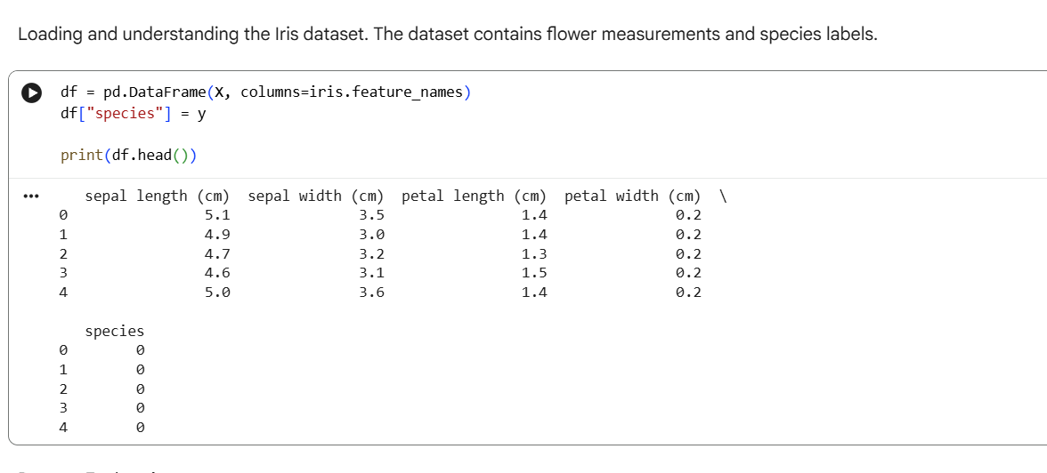
Screenshot 2: Dataset Exploration
The following screenshot shows the dataset shape, dataset information, and statistical summary used to understand the dataset before model training.
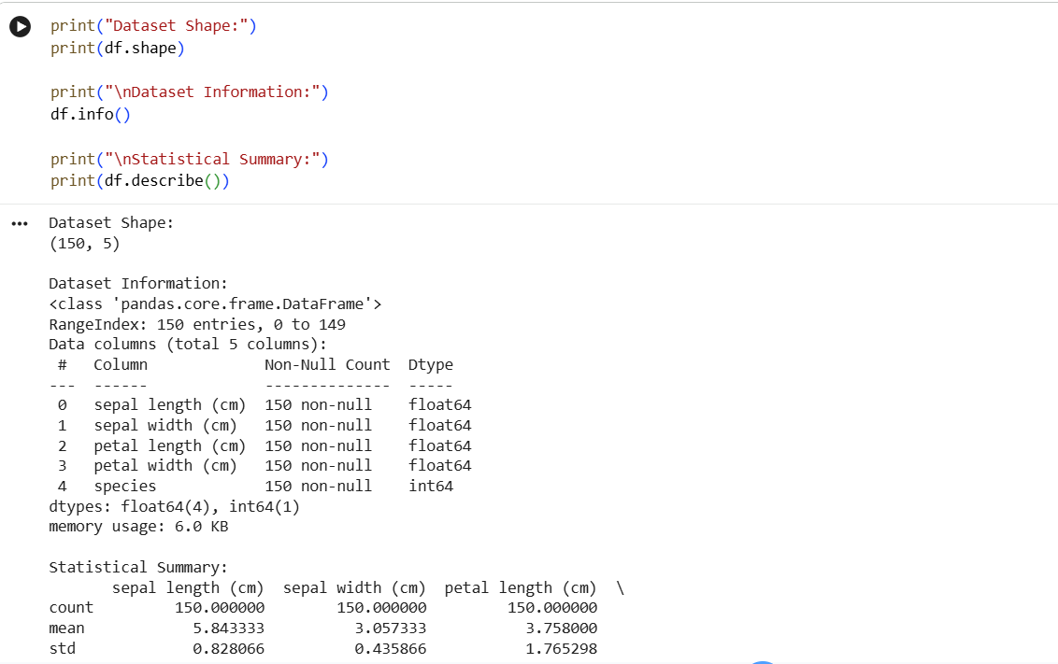

Screenshot 3: Model Evaluation
The following screenshot displays the model accuracy, classification report, and confusion matrix generated after evaluating the trained Decision Tree Classifier.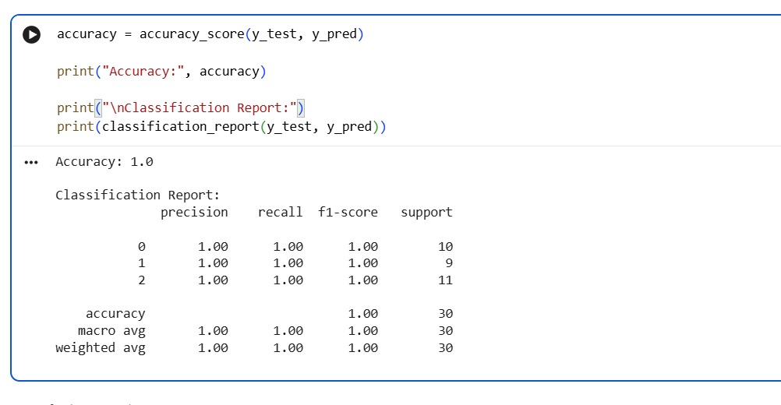

11. Real-World Applications
Classification models are widely used in many industries.
Examples include:
• Email Spam Detection
• Medical Diagnosis
• Fraud Detection
• Customer Segmentation
• Image Classification
• Product Recommendation Systems
• Credit Risk Analysis
• Sentiment Analysis
The concepts learned in this project form the foundation for advanced Artificial Intelligence systems.

12. Challenges Faced
During the project, understanding the machine learning workflow and evaluation metrics required careful study.
Additional effort was spent learning:
• Dataset handling
• Data splitting
• Model training
• Classification reports
• Confusion matrices
These challenges helped strengthen practical machine learning skills.

13. Future Improvements
Possible future improvements include:
• Testing multiple classification algorithms
• Hyperparameter tuning
• Cross-validation
• Working with larger datasets
• Feature engineering
• Model comparison studies
These enhancements can further improve model performance and understanding.

14. Conclusion
This project successfully demonstrated the implementation of a classification model using the Iris dataset.
The dataset was loaded, explored, and divided into training and testing datasets. A Decision Tree Classifier was trained and evaluated using accuracy score, classification report, and confusion matrix.
The model achieved excellent performance and successfully classified flower species based on their measurements.
This project strengthened understanding of supervised learning, data handling, model training, prediction, and evaluation, providing a solid foundation for future machine learning and Artificial Intelligence projects.

15. GitHub Repository
GitHub Repository Link:
https://github.com/NallaVaishnavi/DecodeLabs-Internship-Project2

